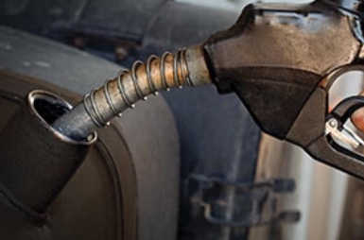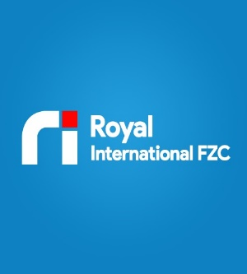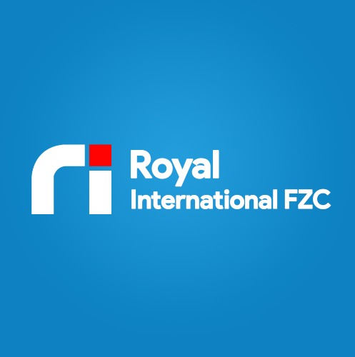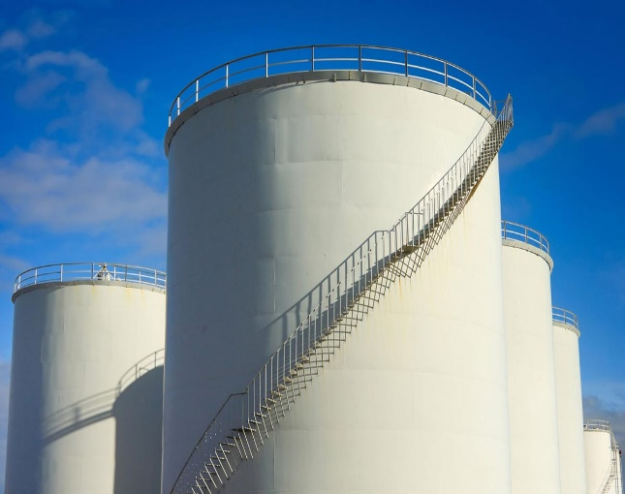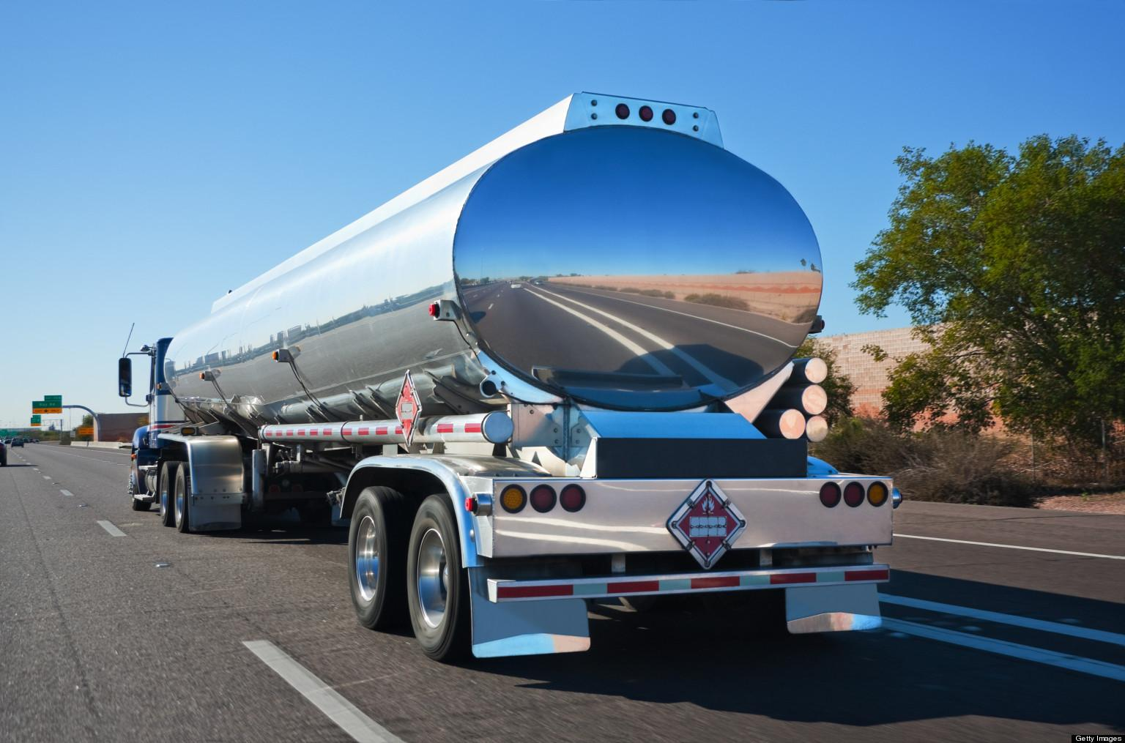

OIL & DIESEL FUEL SUPPLY

ROYAL INTERNATIONAL FZE is an oil and Diesel Supplier based in Sharjah, UAE, since 2019.

Extended to supply reputed construction, contracting, transport, heavy equipment’s and other related company vehicles, machineries, generators etc.

Quality service is our outline of success.

Our Diesel Supply solutions for specialized companies can help you to meet your requirements, goals and satisfy your fuel needs.

Custom made truck tanks have an advantage over off-the-shelf products in their adaptability and cost. Our Clients enjoy a high level of satisfaction and our drivers supply on time to meet up your needs.





Our values are consciously held and consistently applied

Our actions are driven by these values:

* Integrity: We demonstrate ethical, fair and transparent behavior.
* Ownership: We are committed to continuously finding new and better ways to deliver value to the business;
* Performance: We actively pursue, define, measure and recognize excellence in all business activities.

Royal international Fze is capable of meeting the satisfaction of our valuable clients. Our extensive experience and proven track record in Bulk Fuel Distribution stand us in good stead to meet and exceed any client’s expectations.

We aim to consistently delight our customers by providing service of an unwaveringly high standard, while conducting our business practices in line with our values. We aim to foster mutually beneficial partnerships with our customers, believing that it is only when we deliver great value that we maximize the long-term sustainability of Royal International Fze.

**

ROYAL INTERNATIONAL FZE

HAMRIYAH FREEZONE

SHARJAH – UAE

TEL : +971564548601, email : sales.royaluae@gmail.com

*